**Renata Hejduk**

Arizona State University

**Haus-Rucker-Co. (1967-1992)**

Beginning around 1960, incredibly experimental design work began to emerge from Austria where a strong modernist tradition existed (with the work of Otto Wagner and the Vienna Werkbund) and a rich experimental tradition emerged with the work of Frederick Kiesler. Despite these strong traditions, the architectural educational and building system in Austria was quite conservative and not particularly forward focused after World War II. Haus-Rucker-Co. emerged from the Austrian student activism that reacted to this conservatism. Architects Laurids Ortner and Gunter Kelp (pseudonym ‘Zamp’) and the painter Klaus Pinter founded the group in 1967. The name refers to the Hausruck Mountains that run through the area in Austria where the members originally lived. The term Haus Rucker could also mean House Mover in High German or House Thief in Middle Low German. Either of these meanings offer us a rich definition through which to read the work of this radical avant-garde practice.

Primarily, they used pneumatic objects that were an easy, flexible, provisional, and transitory way to create an environment for their events and actions. They termed their research the ‘Mind Expanding Program’, which looked into how their projects could expand and inform the user’s experience of the urban environment, as well as create and heighten relational experiences and communication between and among people. Like most of the other radical groups of the period, they began their research in 1967 with projects that were still quite fixed and architectural, and developed toward work that eventually did away with fixed forms and permanent constructions. Two of their best-known projects debuted in 1967-68: *Pneumatic Space for Two People* (aka *The Mind Expander*) and *Pulsating Yellow Heart*.

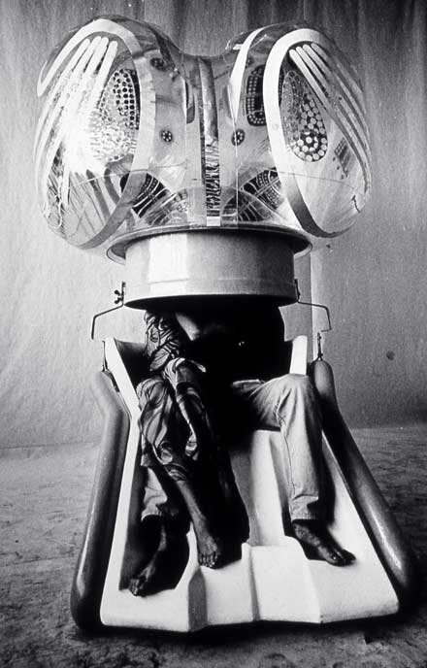

*Mind Expander*, Vienna 1967. Image courtesy of Zamp Kelp.

Pulsating Yellow Heart.tif

*Pulsating Yellow Heart*, Vienna, 1968. Image courtesy of Zamp Kelp.

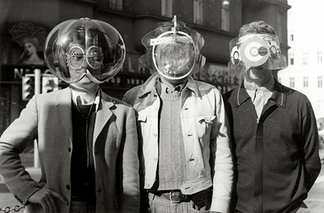

*Fly Head, Viewatomizer, and Drizzler*, 1968. Image courtesy of Zamp Kelp.

At the same time, they experimented with devices/environments that were worn by a single user. The *Environment Transformers: Flyhead, Viewatomizer, and Drizzler* are appliances that were equipped with headphones and coloured glasses that created an intense optical-acoustical sensory experience for a limited time. Like the British group Archigram, the transportable environments that astronauts wore inspired them, and the fact that the astronauts were ‘able to experience a new space with the help of technology, as a model of “consciousness expanding” architecture.’[1]

They believed that it was now feasible (through the help of advanced technology) to steer consciousness through architectonic devices. Their work joins that of the other radical avant-garde groups of the time with their critique of bourgeois life and dwelling. The group’s New York office dissolved in 1977 and the Dusseldorf office in 1992.

List of Key Works:

Balloon for Two, 1967

Pneumatic Space for Two People (aka) Mind Expander, Vienna, 1967

Pulsating Yellow Heart, Vienna, 1968

Fly Head, Viewatomizer, and Drizzler, 1968

The Giant Billiard, 1970

Haus Rucker, Live Living, Members of Haus Rucker ‘Living in the Museum’, 1970

Oasis #7, Documenta V, 1972

References for further reading:

Klotz, Heinrich. Haus-Rucker-Co: 1967 bis 1983 (Schriften des Deutschen Architekturmuseums zur Architekturgeschichte und Architekturtheorie), Wiesbaden, F. Vieweg, 1984.

1. Laurids Ortner, “On New Space” essay for the exhibition *Haus-Rucker-Co:Live again* 16 November 2007-16 March 2008, Kunstmuseum Linz.